Participant’s Online Account

Participant Online Account Overview

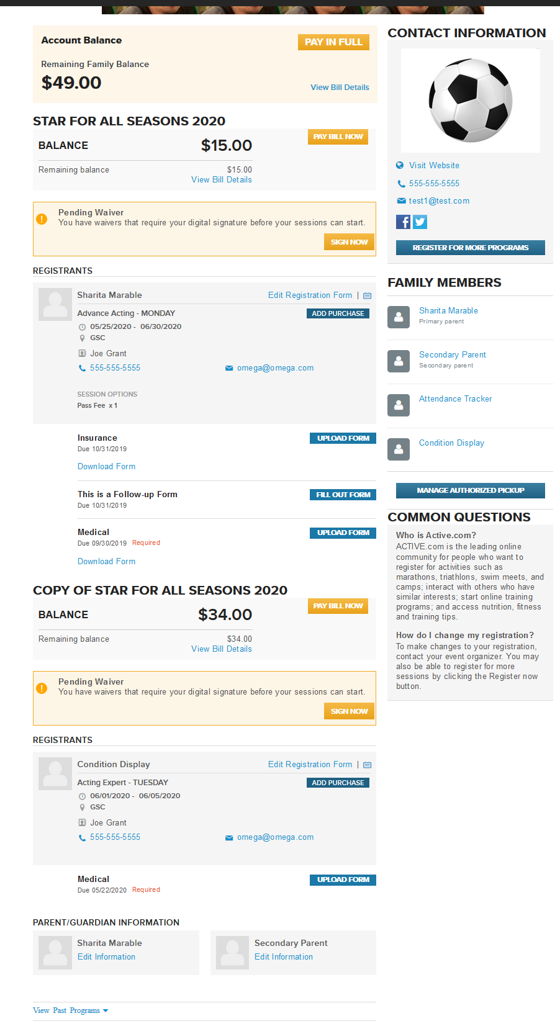

Accessing online account
- To access your online account, you will need the online account link. The link can be located at the bottom of your confirmation email.
Note: Confirmation emails are received after completing a registration online. If you’re a new user and was internally registered by an organization Admin, you will receive an invite email after the confirmation email that prompts you to create a password/online account.
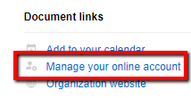
- The organization can also provide the online account link.
- The online account link takes you to the login screen.
- Reset your password on the login screen by clicking Forgot your Password?
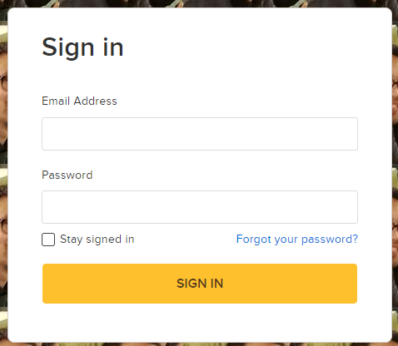

Make a payment
- There are 2 options to make a payment.
  - Pay in Full - When there are multiple unpaid orders, you can pay the account/family balance total.
  - Pay Bill Now – This option allows you to make a custom payment towards one order or multiple orders.
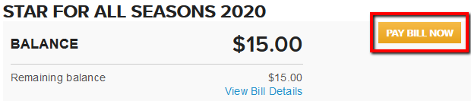
    - When A Custom Amount is selected, and the order has more than one registration you can manage the allocation of the custom amount manually.
      - EX: If you’re making a $10 payment, and have 2 programs with a balance, you can allocate $5 to both programs.
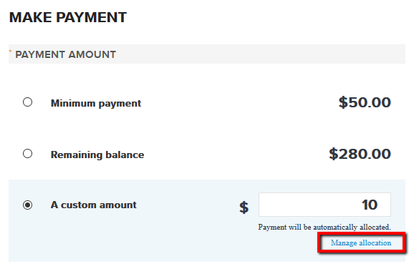
    - Distribute the custom amount between multiple programs or allocate to one program. The remaining amount to allocate must be $0 to continue.
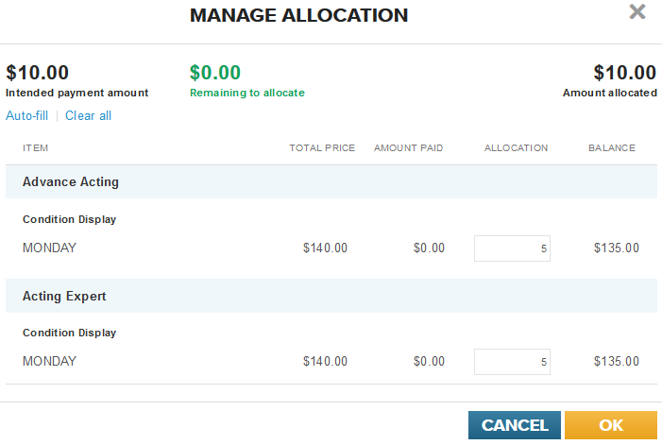

Default Payment Allocation
  - When a custom payment is made without utilizing the Manage Allocation feature, the system will automatically allocate it towards the most expensive line item (session/program) first.
  - If all line items cost the same amount, the system will allocate the payment to the session/program who’s start date comes first.
  - If the program’s/session’s cost the same amount and have the same start date, the system will then allocate the payment to the one listed first on the order.

Manage Payment Plan(s)
- Orders on a payment plan are visible in the online account.
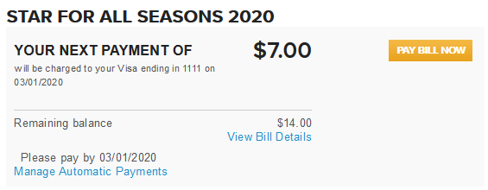
  - Click View Bill Details to see remaining payments.
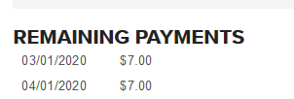
  - Click Manage Automatic Payments to Update Card on File.
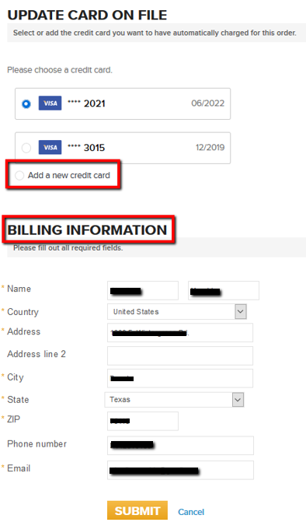
- A payment is not required to update a debit/credit card on file.

Print Order Details
- Print detail information per order.
  - To access
    - click View Bill Details under Account Balance or season balance.
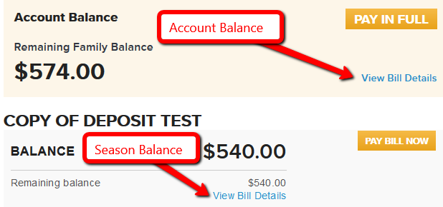
    - Then click View Order Details
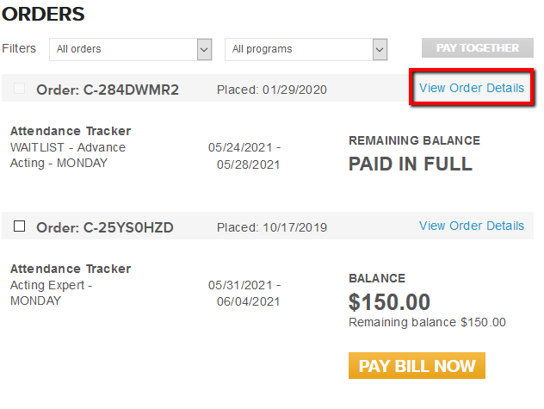
    - Lastly, click Print
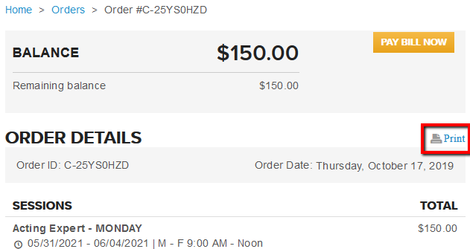
  - Includes, Payments and Balances
  - Session name, date, location, cost and contact info

Add Purchase
- Items, such as merchandise and session options, can be purchased in the online account after registration.
  - EX: clothing, equipment, lunch items, after school options, etc.
  - If Items aren’t listed, contact the organization for a different way to purchase.
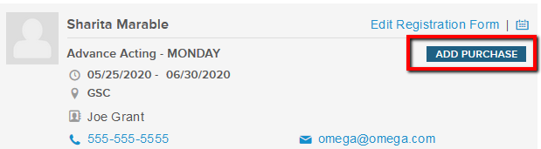
  - A full payment, for the additional items, is required at the time of purchase.

Submit a Follow-up Form
- Follow-up forms are completed in the system.
  - The format is like the registration form during registration.
- It will be displayed under applicable session(s)
- Fill Out Form will be grayed out if it’s no longer available/overdue.
  - Overdue means the expiration date set by the organization has passed.
  - Contact the organization for assistance.

Upload a Supplemental Form
- Supplemental forms need to be downloaded first then uploaded.
  - After form(s) are downloaded, print form(s).
  - Next, fill out form(s).
  - Scan or take a picture of completed form.
  - Then, upload the form (or picture of completed form) back into the system by clicking Upload Form
    - Form(s) will need to be saved to your device before uploading.
  - Click Submit
    - Note: Make sure all files you want to submit are uploaded before clicking submit. You won’t be able to upload additional files after you click Submit.
- 20 files can be uploaded at one time.
  - The maximum size, per file, is 7MB.

Upload a Photo
- There are 2 options to upload a photo.
  - Click on the blank profile image next to the participant’s name.
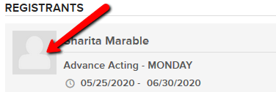
- Or click on Edit Registration Form, then click the blue Upload Photo tab
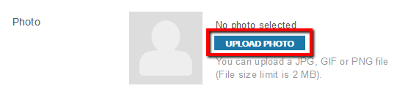
- Acceptable files are JPG, GIF and PNG.
- The maximum file size is 2 MB.

Edit Registration Form
- Edit answers from the Registration form and Follow-up form.
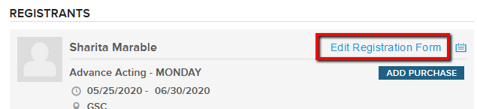
- If Edit Registration Form isn’t visible, the organization hasn’t enabled this feature.
  - Contact the organization for assistance.

Add/Edit a Secondary Parent
- Adding a secondary parent is only an option if it wasn’t added during registration.
  - The Secondary parent can receive email communication from the organization.
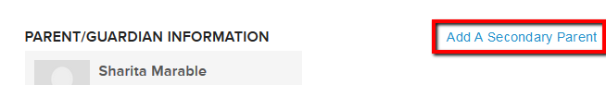
- Once a Secondary Parent is added it cannot be removed but can be edited.
  - The Primary and Secondary parent’s email address, phone number and photo can be edited.
  - Contact the organization if you want to edit the contact first and last name.
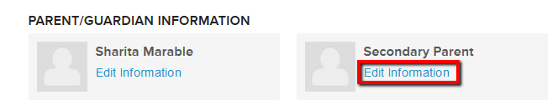

Manage Authorize Pickup
- Manage who can pick up participants.
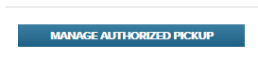
- Add a pickup person for participant after registering.
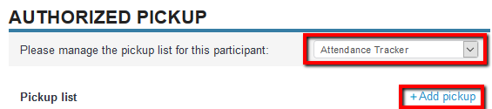
- Change the Authorization at any time by clicking on the Authorization status.
- Make changes to their name and/or phone number by clicking Edit.
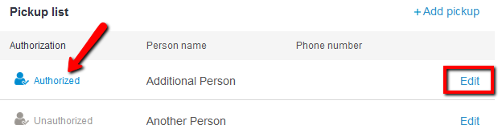

Sign Pending Waiver
- If a participant under 18 years of age is registered internally by Admin from the organization, the parent/guardian will be able to sign the waiver in the online account.
